Welcome to the Somerset You can Do Services.

May I take this opportunity to thank you for becoming a volunteer with Somerset ‘You can Do’ I hope you enjoy being part of this exciting and innovative service we have developed in partnership with Somerset County Council.

As a volunteer, we will be inviting you to fully participate and help us with the on-going evaluation of the service. Somerset You can Do are funded until September 2014.

Please feel free to contact us if you have any comments or concerns about your volunteering or if you would simply like to find out more about the opportunities we have to offer. The team will be very happy to talk to you, either on the phone or by arranging a meeting.

The team is made up of the following people

Bryan Mitchell - SYcD Services Manager 01278 664182

Peter Wood - Senior Services Development Officer 01278 664181

Sue Hunter - Service Development Officer 01278 664183

Marilyn Stephens- Service Development Officer 01278 664180

Patti Hodgson - Service Development Officer 01278 664180

Vanessa Norton- Service Development Officer 01278 664180

Jenny Wood- Service Development Worker 01278 664180

Brenda Fowler - Volunteer Development Worker 01278 664180

Thank you again and I am delighted that you have chosen this way of helping other people in your local community.
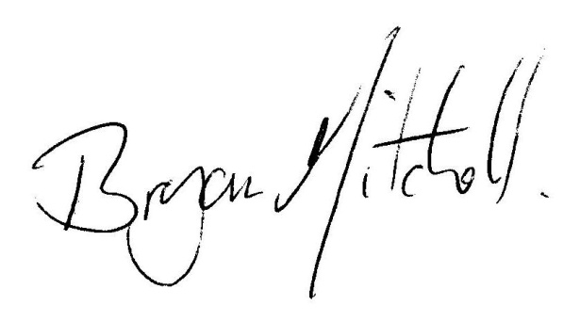
Regards
Bryan Mitchell
SYcD services manager

